USAID MULU_ Key Population Activity

From Oct. 1/2022 to September 30/2023.

Annual Report

LIP: ISHDO (Former ISAPSO)
Contact Information for this Report

(F/Mariam Workagegn)
(M & E Coordinator)
(0911943641)

Date submitted 26/10/2023

Contents
1. Background 4
2. Accomplishments during the reporting period 6
2.1.1 Meetings: 6
2.1.2 Trainings 7
2.2. Behavior Change Communication Interventions (BCC): 7
2.2.2. Cascading sessions: 7
2.3. Condom Promotion and distribution activities: 8
2.4. IE/BCC material distribution: 9
3. USAID MULU: _ KP activity Integrated Clinical Service 9
3.1. HIV Counseling and Testing: 9
3.2. Successful referral Services for STI, HIV and Family Planning: 11
3.3. DIC services: 12
3.4. Test and start at DIC 12
3.5. HIVST promotion and Distribution 13
3.6. PrEP Service 13
3.7. Gender Based Violence/ GBV 14
4. MULU HIV Prevention Project Structural Interventions 15
4.1. Technical working group/TWG meeting: 15
5. Environmental Compliance issues 16
6. Monitoring and Evaluation 16
6.1. Reporting 16
6.2. Data Quality issues during the reporting period: 16
6.3. Project activity monitoring and supportive supervision: 17

Background
According to 2018 EDHS estimates, adult HIV prevalence in Ethiopia is estimated to be 0.9%. Prevalence varies significantly by region where some regions have much higher prevalence (4.8% in Gambella and 3.6% in Addis Ababa). The estimated number of PLHIV who live in urban and rural areas in 2018 is 475,066 (63.6%) and 275,280 (36.9%) respectively, with higher HIV prevalence in urban setting than rural, and gender (1.9% female versus 1.0% male during 2011).
The HIV epidemic in Ethiopia is primarily associated with areas of urban concentration (5.1%) HIV prevalence in cities with a population >50,000 compared to 3.1% in smaller cities and 0.6% in rural areas) and proximity to major transport corridors. Gender based violence, transactional sex, high levels of mobility and migration, low perception of risk, stigma and discrimination, low levels of condom use and a lack of key and priority population friendly HIV services are key drivers of the epidemic.
Key and priority population: Female sex workers are disproportionally have higher HIV prevalence; one every four female sex worker is HIV positive (EPHI 2013). The USAID funded MULU/MARPs program HIV case identification rate for female sex workers is above 5%, of these, 99% are newly diagnosed. The 2017-point estimate for new HIV infections is 22,827; during FY17, MULU provided HTS for 105, 500 individuals and identified 3,817 HIV positives. More than 86% have been linked to ART initiation which has played a critical role in identifying and linking PLHIV and fill in treatment gaps in the country. This is 17% of the national new HIV infections occurring, just implementing its intervention only in 72 towns and only among FSWs and PP; which is a sign of efficiency. The new infections identified and linked to treatment leads to the success of the first and second 90s. MULU put 1274 female sex workers PLHIV on treatment at its 25 community DICs as part of its commitment to the second 90s. Of these patients on treatment, 91% achieved viral suppression (third 90) through our collaborative sample transportation to public networked facilities. Addressing sexual networks through innovative approaches including index case testing, peer led strategy and HIV self-testing at our community DICs has been critical for the accomplishments. The MULU intervention has been aligned with the national epi of urban and female with elevated HIV prevalence towns and population groups.
The USAID key and priority population project will be implemented in community settings to enhance its targeted testing approach including scale up of index case testing, HIV self-testing and community ART for epidemic control. The community linkage between female sex workers and their clients, women engaged in transactional sex peer networks, community level DIC providers and public health and laboratory facilities to enhance the HIV case identification, linkage to treatment and tracking of viral load suppression towards achieving the UNAIDS and PEPFAR goal of 90-90-90 and epidemic control by 2020.
The goal of the USAID HIV Comprehensive FSW/PP Activity is to expand community-based HIV services for Female Sex Workers and Priority Populations, (which include FSWs and their partners and children, their clients, truckers, high-risk employees at commercial worksites, women who engage in transactional sex, and out of school adolescent girls and young women (OSYYG) that are not in the female sex workers cohorts).
The main objective of, ISHDO is contributing to the efforts made in the country in reducing the spread of HIV` in line with the Ethiopian prevention policy. ISHDO had a long-time experience and contribution in the current promising result the country has achieved. The organization has different project execution and implementation experience with different international organizations. It has been evaluated and witnessed its maximum potential.
Therefore, this project has been prepared in response to contribute to the national target of reducing new infections by 60 % through provision of a range of standard combination prevention services to FSW and priority population in surrounding hotspot areas. This project is funded by PSI /USAID.
The minimum service packages for achieving the goal are the following.
- BCC
- Health product distribution
- Referral and linkages
- Direct clinical service provision
- Drop-in-centers
- Community level training
- Economic strengthening and others

Accomplishments during the reporting period

2.1.1 Meetings:
Annual Planning Meeting for USAID MULU-KP activity were facilitated to see Annual MULU-KP Activity performance and FY23 physical and Financial Plan. All the LIP MULU KP Activity coordinators and sub city representatives from all stakeholders (Health Office, Health center heads and other NGOs working at the sub city) participated in this important meeting. From ISHDO head office Executive Director and Program Manager also participated in the meeting. The LIP present FY22 performance and also the FY23 physical and financial plan. The Executive Director open the meeting and the Program Manager Give direction on overall program strategies and expected results were explained for the participants. Participants were mentioned different concerns that is unclear in the presentations and the LIP representatives and the DIC coordinators explain on the presented questions additional explanation also given from the head office MULU team.
Quarter Review Meeting for USAID MULU-KP activity were facilitated to see quarter MULU-KP Activity performance. All the LIP MULU KP Activity coordinators participated in this important meeting. From ISHDO head office Executive Director and Program Manager also participated in the meeting. The LIP present FY23 Quarter 1 performance, success, best practices, challenges and way forward. The Executive Director open the meeting and the Program Manager Give direction on overall program strategies and expected results were explained for the participants. Participants were mentioned different concerns that is unclear in the presentations and the LIP representatives and the DIC coordinators explain on the presented questions additional explanation also given from the head office MULU team. Q2 plan also discussed by including the remaining targets from Q1 and strategies to accomplish this target
ISHDO Head office technical team together with management team also conducted recognition meeting with DIC Coordinators to see the performance till may 2023, highly performed activities by DIC recognized and low performed activities must be focused for next period.
ISHDO MULU KP Head office team and DIC coordinators from all DICs attended different meetings organized by Addis Ababa Regional Health Bureau and other organizations in different topics. (Annual review meetings organized by AARHB, M & E orientation meetings, Biweekly performance review meetings organized by PSI-E)

2.1.2 Trainings
DMP and ICT Training conducted for 3 days at Adama town to improve the ICT performance and how to do DMP at DIC. DIC coordinators, Community facilitators, clinical outreach workers and case managers participated in this important training. From ISHDO head office Program Manager, BCC Coordinator, ICS Coordinator and M & E Manager also participated. The ICT training was given by PSI-E representative and DMP by ISHDO. The training was interactive and there was good participation from participants. Lastly action plan was developed by DIC level to improve ICT performance by focusing on the root causes.

2.2. Behavior Change Communication Interventions (BCC):
Behavioral change communication interventions are used to bring about a specific behavior change along those unwanted and risk behaviors that increase the risk of HIV and sexually transmitted infections in those selected target groups of the town.
Refreshment training was given for 35 # of PE in N/Lafto, Addis Ketema, Bole and Arada towns, we are conducting the training by 8 topics FSW 5 topics HRM and 6 topics AGYW printed PLGs. The training given in different target group for FSW, HRM, AGYW.

2.2.2. Cascading sessions:
FSW by One-to-One peer sessions: It is a maintenance dose for FSWs with high-risk sexual behavior to address their knowledge gap. This is conducted with in three Weekes with 4 different selected topics to help them reduce their risk behavior. During this year a total of 4,269 participants reached through this session, through in person the peer educator has monthly transport allowance and the peer participants for in person session also have face mask provided from the project.

High Risk Men /HRM: By scale up the peer group discussion to potential High-Risk Men, the session was conducted with the ultimate end of having reducing new HIV infections across the vulnerable group. The session for HRM with an average size of 15-20 members 4,546 participants reached through this session, through in person the peer educator has monthly transport allowance and the peer participants for in person session also have face mask provided from the project.

Gender Norm: by taking 10 % of HRM target gender norm session was target was given for each DIC, this session conducted to improve the participants knowledge on gender related issues and also to prevent GBV. In this reporting period 540 session participants reached by one to one in all DIC.

Adolescent Girls and Yang Women (AGYW): A lot of efforts were made to convince owners and waitresses to come to the discussion sessions by telling them that they are not going to waste their working hours as it is going to be conducted in their non-working hours and the discussion will build their overall knowledge and skills in the area of HIV and STIs using the previous USAID MULU: _ KP activity Asteway manual with 4 sessions. In the session among the Adolescent Girls and Yang Women (AGYW): 3,056 participants reached through this session, through in person the peer educator has monthly transport allowance and the peer participants for in person session also have face mask provided from the project.

MER Indicator | Annual Target | Achievement. | %
KP_PREV | 4148 | 4269 | 102.9%
PP_PREV | 8380 | 8142 | 97.2%

2.3. Condom Promotion and distribution activities:
In peer-to-peer sessions targeted promotion and distribution of condoms to sex workers on 100% Consistent and correct use and promotion of health seeking behaviors through existing DIC, HTC, STIs diagnosis and treatment, family planning and ART services were undertaken.
Correct and consistent use of condom is one of the best choices, mainly to prevent new HIV/STIs infection among FSWs and other priority Population. As a result of this, USAID MULU:_ KP activity promotes correct and consistent use of all forms of condoms & free distribution of PROTECTOR PLUS condom, to FSWs and other priority Population who are exchanging sex at lower cost and likely to practice unsafe sex either during absence or relatively higher cost of condoms. Hence, project staffs have made unlimited efforts to promote correct and consistent use of condoms in the framework through fixed and mobile out lets. Fixed condom outlets, established at selected sites within bed rooms where concentration of FSWs is present, and homes commercial sex is practiced. In addition to this, Youth centers, Hotels, Bars and DICs are also the other place of fixed condom out lets.
Peer education session by, and outreach HCT campaigns are the mobile condom out lets. The major distribution modality is peer educators during peer sessions. Each peer session participant member is provided based on demand of condoms for a week, taking into account average daily consumption and a total of 625,231 Male condom, 459 Lubricants were distributed but there was no female condom distributed in this year.

2.4. IE/BCC material distribution:
Though there is shortage of IE/BCC materials, efforts were made to collect and distribute IE/BCC materials during the peer sessions relevant to different topics in the smart journey (risk assessment), and ‘Asteway’ like (STI), (HIV/AIDS), condom (family planning) and different kinds on HCT campaign, and on meetings organized by HAPCO (DIC service) is continued. Within this reporting period 900 IE/BCC materials were distributed to beneficiaries as mentioned above.

USAID MULU: _ KP activity Integrated Clinical Service
Integrated clinical services were provided in an integrated approach on volunteer bases or provider initiative through Index case testing. To be more clients centred integrated clinical service one window shopping approach is more appropriate. It is provided in different modalities like static, outreach and PICT. The service is targeted to key population/FSW, HRM/ OPPs and other general populations at hot spot areas. The services were provided in static and outreach level. The service was in place in 4 DICs in this quarter, 1 at Abinat, 1at Arada, 1 at N/Lafto, and 1 at Bole. Geneme DIC was closed by the donor and clients shifted to Abinet DIC.

3.1. HIV Counseling and Testing:
Integrated clinical service for MARPs is one and main future of the combination prevention at USAID MULU: _ KP activity the service includes HCT/STI/TB/FP and risk reduction counseling services. There are four DICs at three towns of ISHDO USAID MULU: _ KP activity. These centers besides the services mentioned above provides shower, washing, cooking and napping and entertainment services for FSW. A total of 24,308 clients obtained the HCT services and 777 were found HIV Positive and they were referred to Health facilities for continuum of care. A total of 740 beneficiaries were linked to chronic care at DIC and government health centers. New HIV infection prevention is the main objective of the project and the staff used the new initiatives approach to get FSWs with high risk behaviour and not tested within the last six months. Repeatedly focus on the high hot spot areas was made using the PEs to identify FSWs and bring them to the testing sites through referral at DICs and out reach. The street based FSWs are mostly accesable at night time and by mobilizing the PEs in the streets during night time high number of positive sex workers are found and linked to health facilities. The newly initiated approach to identify positives through Index Case Testing (ICT) was implimented in all project towns and it helps to improve the yeild a total of 3,521 individuals were tested and 375 positives were identified through ICT and 345 of them are linked to cronic care. ICT with 14.5 % contribution to the total test of the project target has 48.3 % positive contribution for the total positives identified during the quarter. This shows clearly ICT has great contribution for positive identification and we have to work and accelerate the ICT performance of the project and also increase the test contribution by that to boost the case finding.
HTS_TST | 27786 | 24308 | 87.5
HTS_POS | 1138 | 777 | 68.3
Linkage | 777 | 740 | 95.2
HTS_INDEX | 10070 | 3521 | 35.0
HTS_INDEX_ POS | 599 | 375 | 62.6
Linkage | 375 | 345 | 92.0

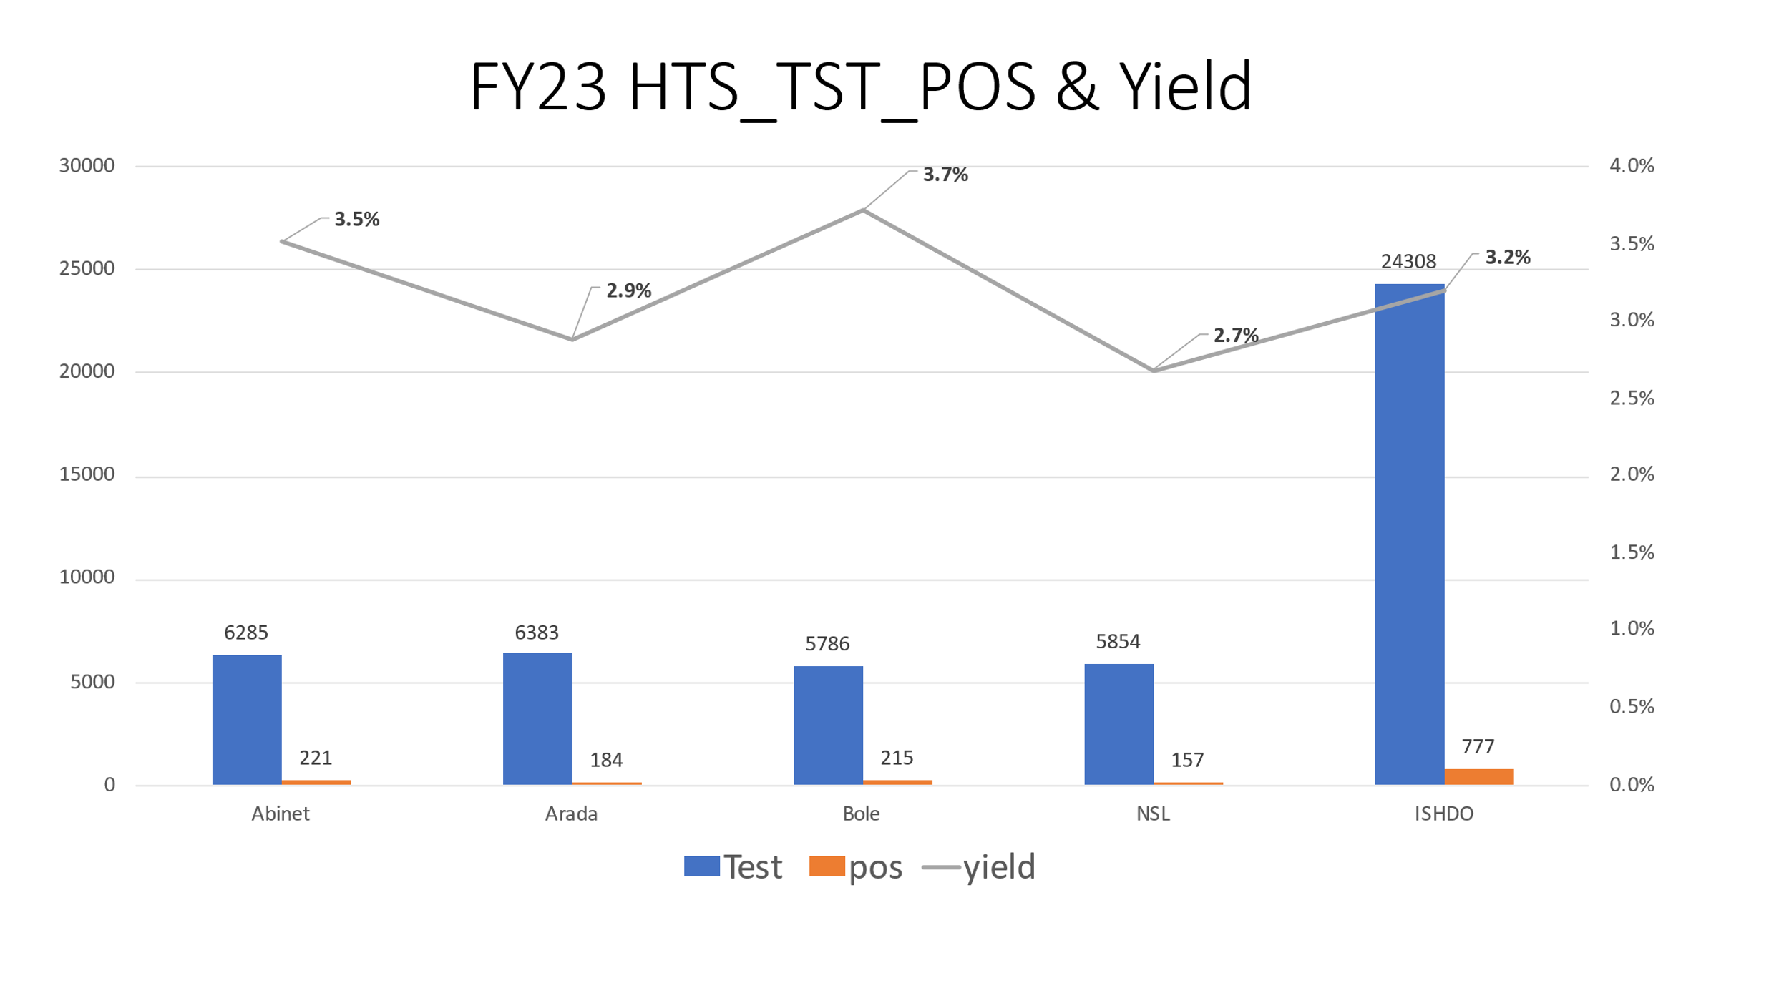
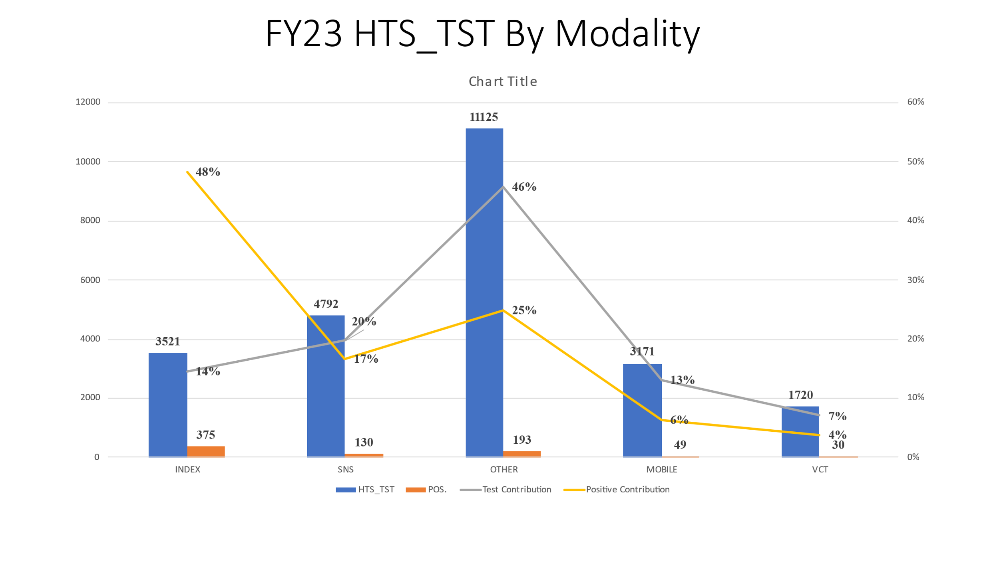
u

3.2. Successful referral Services for STI, HIV and Family Planning:
Referral service, in USAID MULU: _KP activity is an important deliverable which is said to be undertaken as a routine and integral part of the peer learning sessions and at drop-in-center as part of day-to-day counseling effort. Health care providers from public, private and NGO health facilities were identified and trained on Integrated Clinical Service (ICS) to provide service for clients referred from PE, outreach and DIC.
It was also expected that ISHDO will prepare and supply many standard referral coupons to be distributed by peer educators and DIC counselors to all peer education participants and their clients during peer learning sessions and routine counseling sessions. In this reporting year totally 133 clients were referred to other facilities and 96 didn’t start ART service by different reasons.

3.3. DIC services:
ISHDO has five DIC’s & the primary purpose of establishing DIC services is to offer friendly, confidential, comprehensive and anonymous services for commercial sex workers and other vulnerable women and girls. The centers provide opportunities for clients to talk to their peers about similar concerns and receive services on a daily basis; receive information and products for safer sex; learn how to consistently and correctly use condoms, obtain referrals for medical and/or psychological support, and in average about 10-15. FSWs per day use the services at DICs. Group Health Education Session was given at the DICs twice per week.
TV watching, use of kitchen for cooking, taking rest/nap, washing clothes, coffee-tea program for CSWs, Entertainment were additional services available at the DICs.
In this reporting period, different new and repeat sex workers and PP have got different DIC services and have got risk reduction counselling services.

3.4. Test and start at DIC
Test and start activities conducted in Five DICs at Addis Ketema, Abinet, N/Lafto, Arada & Bole towns. Clinical staffs are working in all DICs which comprises health care providers, druggist, lab technicians and case managers. Equipment’s are available at all DICs and all of them were fully functional. A total of 740 positive individuals were linked to chronic care in this year, 644 Started ART service in these DICs. The rest of individuals are linked to government Health facilities.
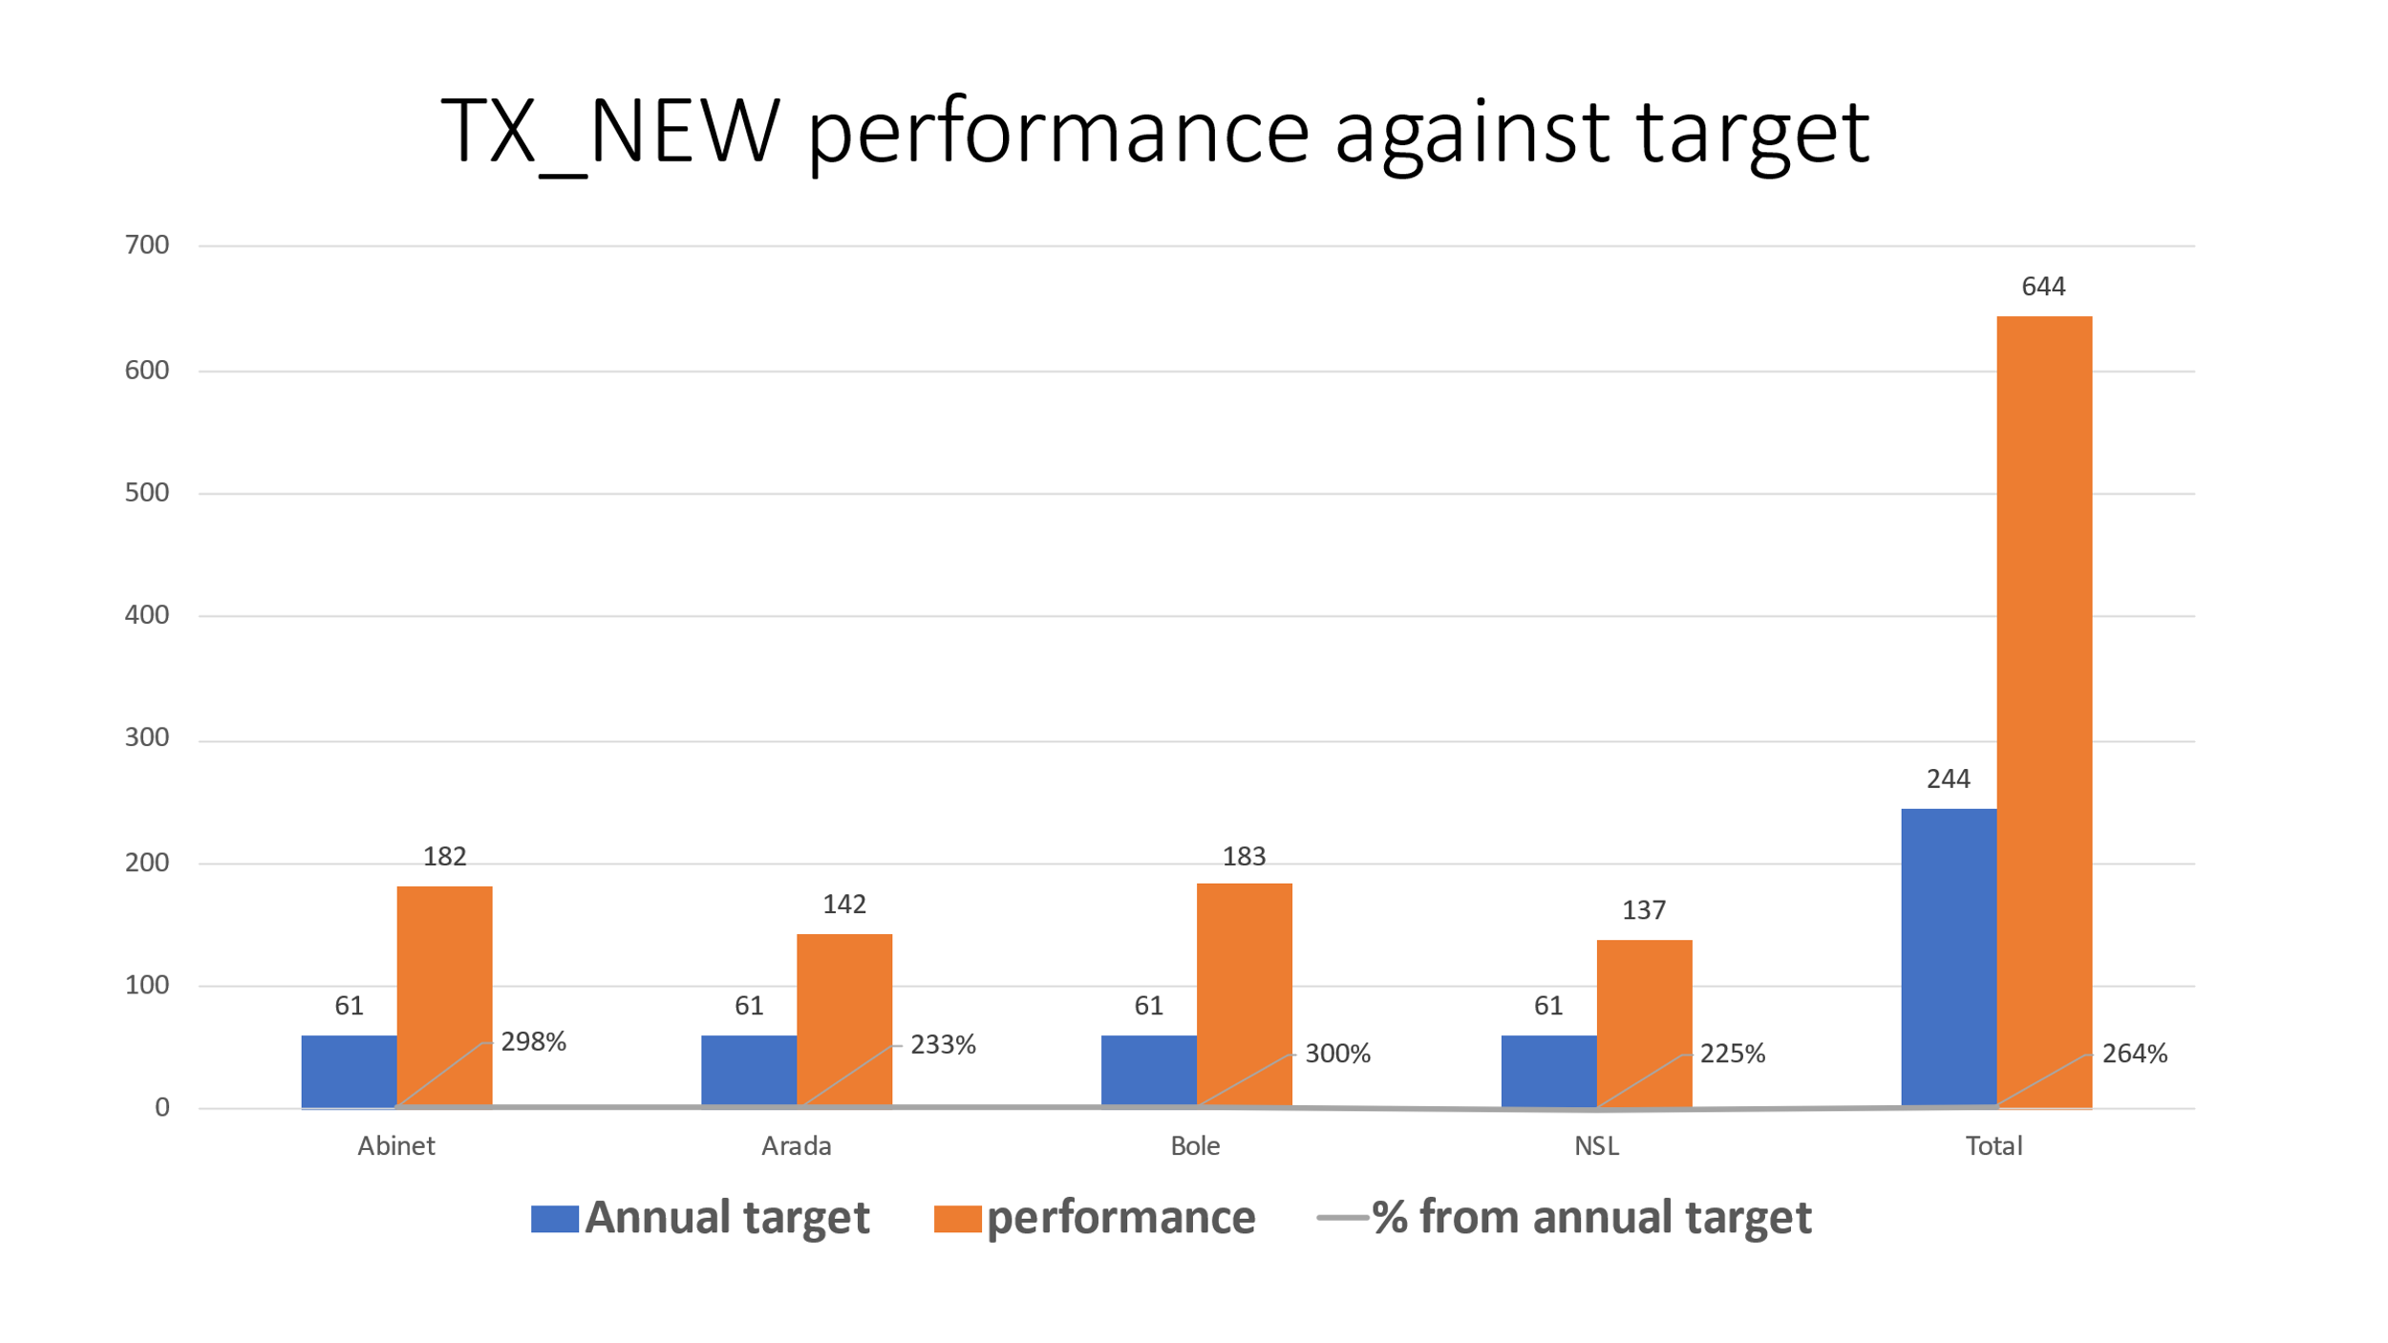

3.5. HIVST promotion and Distribution
HIV Self-test by assisted & unassisted was conducted throughout the year and providers and community volunteers are participated in demanded creation and kit distribution. To create awareness and increase utilization of HIVST, advocacy and communication strategies should aim to emphasize on correct usage of the self-test kits, and ensure correct interpretation of results and create awareness of the need for linkage for additional testing, HIV prevention, care and treatment. During this reporting period a total of 1,568 clients tested by assisted self-test and 21 positives identified and they confirmed through conventional testing and all are positives. 19 clients linked to chronic care. 739 kits distributed through unassisted and there were no positive identified.

3.6. PrEP Service
PrEP (pre-exposure prophylaxis) is conducted in all DICs starting from October 1, 2021.it is given for peoples who are at risk for HIV to prevent getting HIV from sex. PrEP is highly effective for preventing HIV.in our cases the target groups are HIV negative FSW and Discordant couples. In this reporting period a total of 1,638 beneficiaries started PrEP service in all DICs. Currently a total of 1,563 beneficiaries are taking the services.
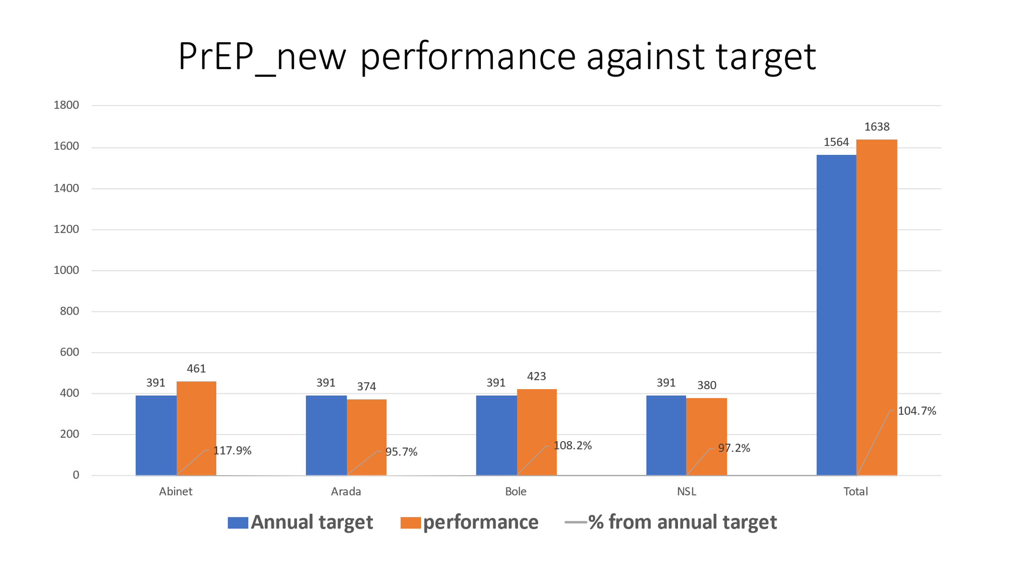

3.7. Gender Based Violence/ GBV
GBV is a common practice among FSW community and it is under reported and disclosure is not common. The activity needs to intensify gender norms and GBV sessions were incorporated in one to one, group sessions and economic strengthening session guides and were conducted to create a continuous awareness on Gender Norms and GBV response for both FSW and PP. GBV screening activity were part of the clinical screening for every FSW/PP attending services at DICs, outreach service and private facilities. The health care providers in the DIC and private facilities were trained to perform GBV screening using a list of questions and peer educators were oriented to conduct a sensitization role in bringing FSWs/PP to GBV prevention and treatment services if any GBV encountered in the community. Beneficiaries who reported GBV during screening were provided counseling at the site and referred for the different psychosocial, legal services mapped out in the specific towns and the community mobilizers ensures appropriate service is provided.
In this reporting year a total of 242 GBV cases were identified from this 10 were sexual case and 232 were Physical and emotional cases. PEP service was given for 8 sexual cases the two cases were not given since they were ART clients.
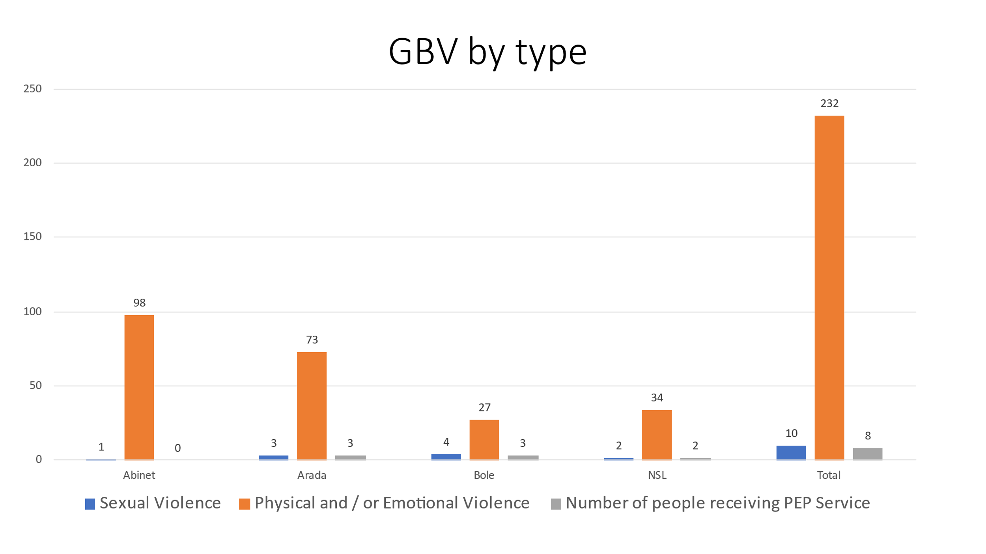

MULU HIV Prevention Project Structural Interventions
In this reporting period, no saving groups newly established but there are individual saving activities at all towns was facilitated different amount of money and individual bank account encouraged and supported by DIC staffs at each town.

4.1. Technical working group/TWG meeting:
The basic significance of TWG is to support, monitor, and coordinate HIV prevention projects. It comprises different stakeholders Government sector like HAPCO, Health office, Women affair, Small scale enterprise, Saving institution, Justices and other concerned bodies. NGOs working on HIV prevention are also parts of this technical working group. This group was initiated and organized in all USAID MULU: _ KP activity implementation towns of ISHDO. In this reporting period the meeting was conducted in all DIC. Representatives from sub city health office and selected referral health facilities attended the meeting. FY23 performance till may 2023 presented by DIC Coordinators and discussed on issues raised and also linkage problem was discussed and resolved.

Environmental Compliance issues
Environmental issues are in consideration while implementing USAID MULU: _ KP activity. Orientations were provided for staff and PE on the environmental impact minimization during the execution of the project. Safety boxes and bio-hazard bags are utilized in the management of clinical wastes (E.g., clinical services of DICs and outreach activities) where properly managed after utilization. Condom focal person has been assigned to monitor condom distribution and proper utilization and dumping after utilization. Out-reach HIV testing activities conducted in accordance with the national and/or international guidelines to address environmental adverse effect.

Monitoring and Evaluation

6.1. Reporting
One of the project activity is reporting the performances for different stakeholders like PSI-E, Government and management bodies in the organization. In this reporting period biweekly reports, monthly reports and quarterly reports were collected, verified and send to PSI-E and Government bodies, one of the reporting tool in this project is COMM Care data base and all the reporting indicators (Clinical, BCC, ICT, ART and PrEP) were entered in this period and also data correction were requested for modified and duplicated data’s for project HOPE.

6.2. Data Quality issues during the reporting period:
Data quality management is a very top endeavor in the project monitoring and evaluation activities. Hence, major proper data quality principles like completeness, standard based, consistence, accuracy time stamped principles were employed to ensure the data quality in this progress report period. Registration of activities on proper tools and on-site visit and data auditing activities are some of the methodologies employed.
To ensure the quality-of-service provision to the targeted at-risk population Data Quality Assurance System /DQAS/ is very important. To monitor the day-to-day activities of DIC different tools and materials are used which is developed and provided by the head office under the project to record the activities on daily, weekly, monthly bases in the reporting period. The tools used for reporting system which are important to ensure the data quality by comparing from daily activities recording, registration and tally sheets with the log-books and reported monthly activities are undertaken in the reporting period. Data quality assessment was also done in all towns by ISHDO M&E team, the team tried to see the 3 months reported data with the source document, after the assessment action plan was developed for those gaps identified.

6.3. Project activity monitoring and supportive supervision:
Monitoring and evaluation is a critical project management of the organization. During this reporting period, there was a supportive supervision by ISHDO management, USAID MULU: _ KP activity head office and M&E team in order to visit services to check the data and documentation, progress and services quality. During the visit, vital lesson was learned and future improvement is also taking place as per the recommendations.
Supportive supervision was conducted in all USAID MULU: KP activity towns to support the HTC activities by focusing on targeted testing and to have better yield.
Data quality tool test done at Arada DIC by USAID visitors and excellent feedback was given.
SIMS visit conducted at Abinet and Bole DIC by USAID and Good feedback was given except data quality issues like inconsistency at Bole DIC.

Challenges
- Linkage to Government facility
- ICT clients Eliciting problem
- COMM care data entry at regular bases
- Data Quality problem
Actions Taken
- Develop smooth communication with referral sites
- Improve communication skill in ICT client elicitation to increase contact number
- Encourage staff timely data enter for each activity they engaged
- Communicate with DIC staffs and verify the source document and data correction request was sent and corrected
Best Practice
- Daily telegram reporting and monitoring helps to monitor performance and challenges timely and give immediate solutions
- Weekly and bi weekly performance review helps to assess performance and to bring solutions for identified gaps on time
- Monthly RDQA to improve data quality by ISHDO & Psi.
Lessons learned
- Performance review and re-planning of each DIC
- M&E and program team support sites at regular bases
- Monitoring daily report at head office and give immediate solution for identified gaps.
- Performing additional mini outreach including weekend days, engaging manpower from Gov’t to improve case finding.
- Integrate HIVST distribution, PrEP with BCC activities
- Conducting regular RDQA improves quality of data at each towns
Partnership with Stakeholders
- Annual planning meeting conducted with gov’t representatives and FY22 performance and FY23 planning presented
- DIC staff participate in Catchment area meeting, technical working group meeting and present their performance,
- Reports are send / DHIS2, HMIS, Quarter narrative reports/
Way Forwards
- Strengthen ICT Activities & Case finding
- Linkage verification and follow up of positives
- Lost to follow up tracing
- Strengthen ART retention
- Increase PrEP initiation
- Viral Load sent & received
- Improve performance of Unassisted HST distribution
- Improve COMM Care data entry

